* Use this word document and place your code below the screen shot 🡪 submit as usual.

Write a program that plays the popular scissor-rock-paper game.

(A scissor can cut a paper, a rock can break a scissor, and a paper can cover a rock.)

The program randomly generates a number 0, 1, or 2 representing scissor, rock, and paper.

The program prompts the user to enter a number 0, 1, or 2 and displays a message indicating whether the user or the computer wins, loses, or draws.

Allow the user to continue playing or quit.

Here is a sample run: (50 points)

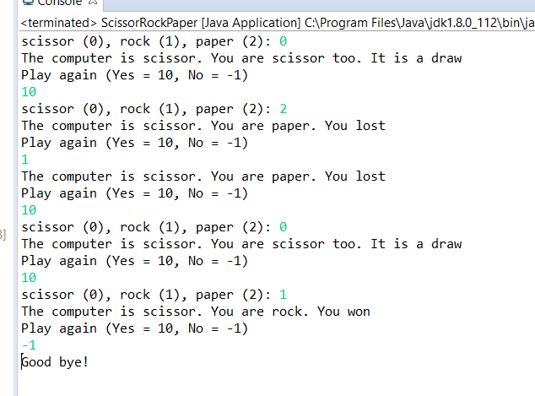

You must use your own screen shot.

import java.util.Scanner;

public class midterm

{

    public static void main (String[] args)

    {

        //array of strings

        String[] move = {"Rock", "Paper", "Scissor"};

        //score trackers

        int playerWins = 0;

        int cpuWins = 0;

        //player's move

        int player;

        //start scanner outside the loop

        Scanner input = new Scanner(System.in);

        //game loop

        while(true)

        {

            //computer's move

            int cpu = (int)(Math.random()\*3);

            //loop displays rules and determines valid player input

            while(true)

            {

                System.out.print(move[0] + " (0), " + move[1] +" (1), " + move[2] + " (2): ");

                player = input.nextInt();

                if(player == 0 || player == 1 || player == 2)

                {

                    break;

                }

                else

                    System.out.println("Invalid Input!");

            }

            //display computer move

            System.out.print("The computer is ");

            switch(cpu)

            {

                case 0:

                System.out.print(move[0] + ".");

                break;

                case 1:

                System.out.print(move[1] + ".");

                break;

                case 2:

                System.out.print(move[2] + ".");

            }

            //display player move

            System.out.print(" You are ");

            switch(player)

            {

                case 0:

                System.out.print(move[0]);

                break;

                case 1:

                System.out.print(move[1]);

                break;

                case 2:

                System.out.print(move[2]);

            }

            //if there is a draw

            if (cpu == player)

                System.out.println(" too. It is a draw!");

            else

            {

               //sets win as true if player wins

               boolean win = (player == 0 && cpu == 2) ||

                       (player == 1 && cpu == 0) ||

                       (player == 2 && cpu == 1);

               //if win is true

                if (win)

                {

                    playerWins++;

                    System.out.println(". You won! You " + playerWins + " : " + cpuWins + " computer");

                }

                //if win is false

                else

                {

                cpuWins++;

                    System.out.println(". You lost... You " + playerWins + " : " + cpuWins + " computer");

                }

            }

            //play again option

            System.out.println("Play again? (Yes = 10, No = -1)");

            int playAgain = input.nextInt();

            if(playAgain == -1)

            {

                break;

            }

            else if (playAgain == 10)

            {

                continue;

            }

            else

            {

                System.out.println("Invalid input!");

            }

        }

        //close scanner

        input.close();

    }

}

